Background

Currently, Qualcomm DC admin prepare Booking Advise from “Qualcomm Hub2000” (option <Data Entry> → <Booking Advise>) and fax it to forwarder to advise them for the freight booking. In return, forwarder will fax freight information (HAWB#, MAWB#, Flight No., ETD/ETA backed to Qualcomm DC admin. After freight confirmation, Qualcomm DC admin will send e-mail to shipper/consignee with CI, Packing Slip and House Bill (NOS – next day to supplier) attachments for pre-alert purpose. No freight information was capture in anywhere of WMS in DC.

Objective

To enhance booking advise prepare/sending, freight information capturing, pre-alert sending process.

Current Process

- Step 1: Prepare Booking Advise in Qualcomm Hub2000
Go to option <Data Entry> → <Booking Advise> and select Forwarder and enter Delivery ID before show Booking Advise on screen. When user enter <Show> button, Booking Advise will be display with assigned booking advise number on top right hand corner. This advise will not save into system after printing, therefore, user is not allow to retrieve Booking Advise based on the booking advise number.

- Step 2: Fax Booking Advise to forwarder
Fax copy of Booking Advise to forwarder and expect forwarder to reply back with HAWB#, MAWB#, FLIGHT No and ETD/ETA info via fax.

- Step 3: Send Pre-alert to Shipper and Consignee
With the softcopy of HAWB (from forwarder), Packing Slip (from Qualcomm DC’s WMS) and CI (from Qualcomm system), Qualcomm DC admin will attached it into e-mail and send to the shipper (Qualcomm) and consignee. E-mail ID defined will depend on the consignee and country.

Proposed New Process

- Step 1: Prepare Booking Advise in Qualcomm Hub2000
Go to option <Data Entry> → <Booking Advise> and select Forwarder and enter Delivery ID before show Booking Advise on screen. When user enter <Show> button, Booking Advise will be display with assigned booking advise number on top right hand corner. In the Booking Advise function, changes make to allow user to enter destination city, NOS needed (Y/N), LC (Y/N) and Charge M2 (Dim / 6000). User can click on <Save> button to save Booking Advise into database. So user is allow to retrieve Booking Advise based on the booking advise number.

- Step 2: Fax Booking Advise to forwarder
Fax copy of Booking Advise to forwarder and expect forwarder to reply back with HAWB#, MAWB#, FLIGHT No and ETD/ETA info via fax.

- Step 3: Enter Freight Info into Database/ Send Pre-alert to Shipper and Consignee.
User needs to retrieve Booking Advise based on the booking advise number and update freight info (MAWB#, Flt#, ETD/ETA and CI number. The freight info is prepared for report COO summary purpose.
Additional functions allow user to attached HAWB, Pack Slip and CI into database and send out pre-alert e-mail to shipper/consignee based on pre-defined e-mail ID in database. User can then click on <Send E-mail> to view the e-mail before send to shipper/consignee.

**Note texts with underline are changes make to the current system/process.

IT TimeLine

IT will raise this as request in ASR and will advise the man-day after user sign off this spec.

Sample of proposed Screen Shoot

Screen to update Freight Info;
-------------------------------------------------------------------------------------------------------------------------
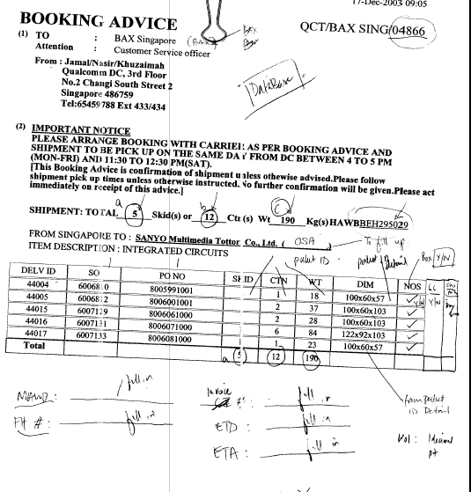

Screen to retrieve Booking Advise and send pre-alert to shipper/Consignee;
-------------------------------------------------------------------------------------------------------------------------
